Lab 3
Abdul Majid
24k-0895
BCS-5H
Task#1:
Server:
import socket
import json
from datetime import datetime

HOST = "127.0.0.1"
PORT = 5000
server_socket = socket.socket(socket.AF_INET, socket.SOCK_STREAM)
server_socket.bind((HOST, PORT))
server_socket.listen(5)

print("Server is running")
print(f"Listening on {HOST}:{PORT}")

while True:
client_socket, client_address = server_socket.accept()
print(f"\nClient connected: {client_address}")

try:
data = client_socket.recv(1024).decode()
if not data:
client_socket.close()
continue

request = json.loads(data)
num1 = request["num1"]
num2 = request["num2"]
operation = request["operation"]

if operation == "+":
answer = num1 + num2

elif operation == "-":
answer = num1 - num2

elif operation == "*":
answer = num1 * num2

elif operation == "/":
if num2 == 0:
answer = "Cannot divide by zero"
else:
answer = num1 / num2

else:
answer = "Invalid operation"

record = {
"num1": num1,
"operation": operation,
"num2": num2,
"answer": answer,
"client_ip": client_address[0],
"timestamp": datetime.now().strftime("%Y-%m-%d %H:%M:%S")
}

try:
with open("calculations.json", "r") as file:
calculations = json.load(file)
except (FileNotFoundError, json.JSONDecodeError):
calculations = []

calculations.append(record)

with open("calculations.json", "w") as file:
json.dump(calculations, file, indent=4)

response = str(answer)
client_socket.send(response.encode())

print(f"Received: {num1} {operation} {num2}")
print(f"Answer sent: {answer}")
print("Details saved to calculations.json")

except Exception as e:
client_socket.send(f"Error: {e}".encode())
client_socket.close()

Client:
import socket
import json

HOST = "127.0.0.1"
PORT = 5000

while True:
try:
client_socket = socket.socket(socket.AF_INET, socket.SOCK_STREAM)
client_socket.connect((HOST, PORT))
print("\nConnected to server")
num1 = float(input("Enter first number: "))
operation = input("Enter operation (+, -, *, /): ")
num2 = float(input("Enter second number: "))

data = {
"num1": num1,
"operation": operation,
"num2": num2
}

message = json.dumps(data)
client_socket.send(message.encode())
response = client_socket.recv(1024).decode()
print("Result from server:", response)
client_socket.close()
choice = input("\nDo another calculation(y/n): ")

if choice.lower() != "y":
print("Client closed.")
break

except Exception as e:
print("Error:", e)
break

Output:
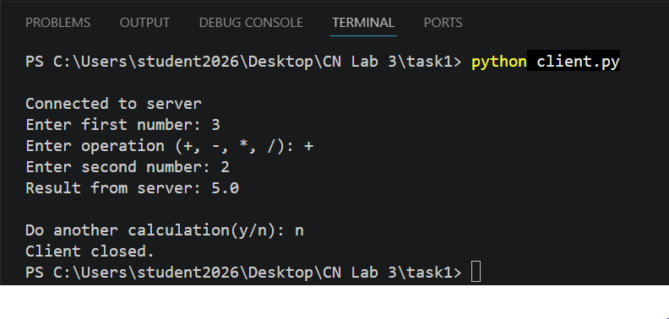
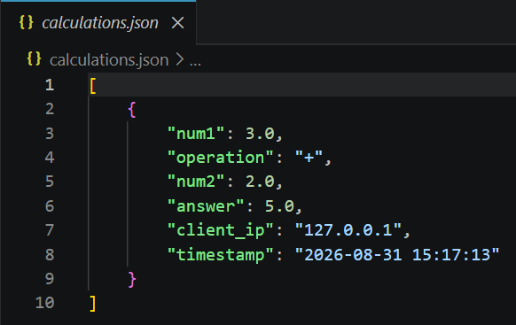

Task#2:
Server:
import socket

HOST = "127.0.0.1"
PORT = 5000

grading_scheme = {
4.33: ("A+", "Excellent"),
4.00: ("A", "Excellent"),
3.66: ("A-", "Very good"),
3.33: ("B+", "Very good"),
3.00: ("B", "Very good"),
2.66: ("B-", "Good"),
2.33: ("C+", "Good"),
2.00: ("C", "Good"),
1.66: ("C-", "Passable"),
1.33: ("D+", "Passable"),
1.00: ("D", "Passable"),
0.00: ("E", "Failure")
}

server_socket = socket.socket(socket.AF_INET, socket.SOCK_STREAM)
server_socket.bind((HOST, PORT))
server_socket.listen(5)

print("Server is running")
print(f"Listening on {HOST}:{PORT}")

while True:
client_socket, client_address = server_socket.accept()
print(f"Client connected: {client_address}")
data = client_socket.recv(1024).decode()

try:
grade_point = float(data)

if grade_point in grading_scheme:
letter_grade, qualification = grading_scheme[grade_point]
response = f"Letter Grade: {letter_grade}\nQualification: {qualification}"
else:
response = "Invalid grade point. Please enter a valid grade point."

except ValueError:
response = "Invalid input. Please enter a numeric grade point."
client_socket.send(response.encode())
client_socket.close()

Client:
import socket

HOST = "127.0.0.1"
PORT = 5000

client_socket = socket.socket(socket.AF_INET, socket.SOCK_STREAM)
client_socket.connect((HOST, PORT))
print("Connected to grading server.")

grade_point = input("Enter grade point: ")
client_socket.send(grade_point.encode())
response = client_socket.recv(1024).decode()

print("\nResult from server:")
print(response)
client_socket.close()

Output:
